**Governor Stirling Senior High School**

**2019 Year 12 Physics**

**Task 5: Test 3 – Electrostatics and Motors**

**TOPIC TEST 3: ELECTROSTATICS AND MOTORS**

**NAME**: SOLUTIONS

**MARKS**: **/50**

**TEACHER**:_______________________

[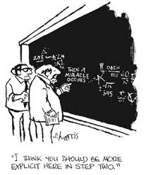](http://www.google.com.au/url?sa=i&rct=j&q=&esrc=s&source=images&cd=&cad=rja&uact=8&ved=&url=http://www.fascinationplace.org/category/hobbies-interests/current-events/&psig=AFQjCNFqsgpNAqidlksaJPy-SZLzmUTR4A&ust=1462890028783697)

* **Answer all questions.**
* **When calculating numerical answers, show your working or reasoning clearly. Give final answers to three significant figures and include appropriate units where applicable.**
* **When estimating numerical answers, show your working or reasoning clearly and give final answers to a maximum of two significant figures.**

1. (3 marks)

The left side of the diagram below shows three sources of magnetic fields.

The right side of the diagram shows three possible magnetic field patterns of the shaded planes.

For each of the three sources, draw a line linking the source to the magnetic field pattern it produces in the shaded region.

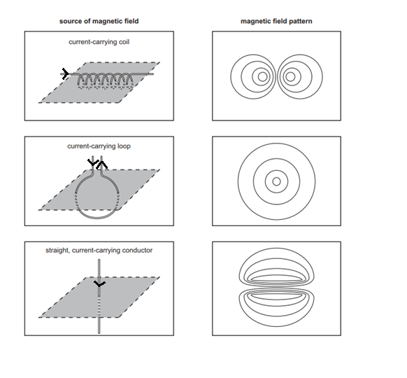



1 mark for each correct match

2. (3 marks)

The diagram below shows a wire in a house carrying a 10.0 A current to an electric hair dryer.

10.0 A

X

Calculate the magnetic field intensity at X, 5.00 cm from the wire, due to the current carrying conductor and state its direction.

B = $\frac{}{2 }$. $\frac{I}{r}$

= $\frac{1.26 x {10}^{-6}}{2 }$ x $\frac{10.0}{0.05}$ ( 1 )

= 4.01 x 10-5 T (1) into the page (1)

3. (3 marks)

A conductor is placed in a magnetic field as shown.

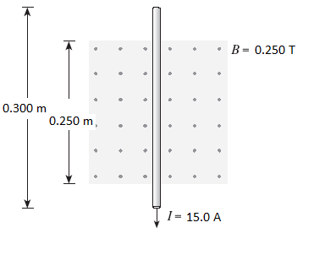What are the magnitude and direction of the magnetic force acting on this conductor when it carries a 15.0 A current?

$F=I l B$

= 15.0 x 0.250 x 0.250 (1)

= 9.38 x 10-1 N (1) Left (1)

4. (6 marks)

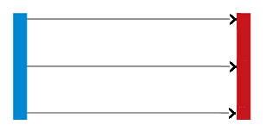A uniform electric field is created by two oppositely charged parallel plates, separated by 0.500 m, as shown in the diagram below:

This electric field has a magnitude of 2.00 x 104 V m-1 and is used to accelerate charged particles. Determine the time a proton would take to travel 1.20 x 10-2 m in the electric field. Assume that the proton starts from rest.

For proton:

$F= \frac{V q}{d}$

= 20 000 x 1.6 x 10-19 (1)

(1)

(1)

= 1.916 x 1012 m s-2 (1)

s

⇒ 0.012 = 0 + (0.5 x 1.916 x 1012 x t2) (1)

⇒ t = ± 1.12 x 10-7 s

i.e. t = 1.12 x 10-7 s (1)

5. (6 marks)

Charge A shown below is +2.00 C and charge B is +4.00 C. What is the total force on a + 1.00 C charge located at point P?

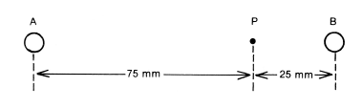

$F_{P from A}= \frac{1}{4 {}_{0}} × \frac{q_{1 }q_{2}}{r^{2}}$

$= \frac{1}{4 8.85 × {10}^{-12}} × \frac{2 × 1 }{{\left(75 × {10}^{-3}\right)}^{2}}$ (1)

= 3.20 x 1012 N Right (1)

(1)

= 5.75 x 1013 N left (1)

∴Total force = 5.75 x 1013 - 3.20 x 1012

= 5.43 x 1013 N (1 ) Left (1)

6. (9 marks)

A student builds a model DC motor. A simplified diagram of her motor is shown in

the diagram below.

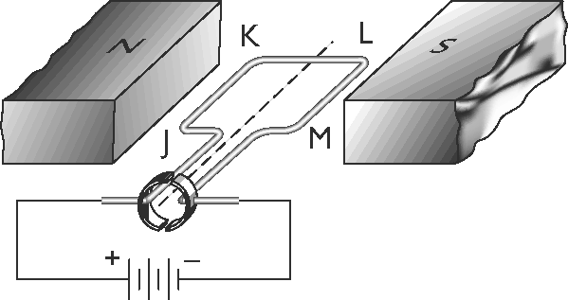The coil of the motor has 50 turns of wire and the magnetic field between the magnets is measured to be 0.0900 T. The length of the side JK of the coil is

4.00 cm, and KL is 3.00 cm. A current of 2.00 A flows through the coil.

(a) Find the magnitude and direction of the force acting on side JK when it is in the position shown in the diagram above.

(3 marks)

F = N I l B

= 50 x 2.00 x 0.04 x 0.09 (1)

= 0.360 N (1) down(1)

(b) Calculate the magnitude of the torque on the coil when it is in the position shown.

(2 marks)

Ʈ = 2 r F

= 2 x 0.015 x 0.360 (1)

= 1.08 x 10-2 Nm (1)

(c) Sketch a graph of the magnitude of the torque acting on the coil for two revolutions of the coil. Use zero time as the position shown in the diagram. (2 marks)

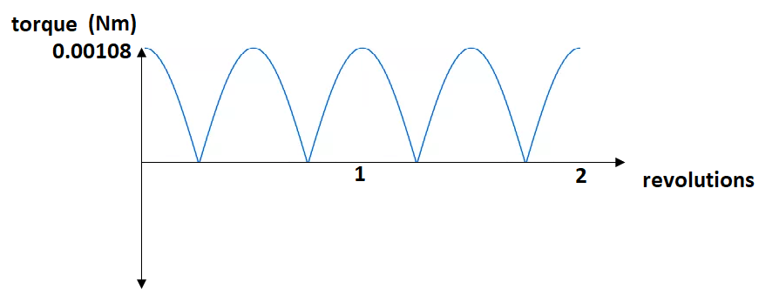

Shape (1) Labelled Axis(1)

(d) What are **two** ways that the torque of this motor can be increased?

(2 marks)

Increase the current in the coil

Increase the magnetic field

Replace coil with one of a larger cross-sectional area

More turns on the coil

Any 2 1 mark each

7. (4 marks)

An electron in a computer screen is accelerated through a potential difference of 7500 V before it hits the screen and transforms it’s kinetic energy to the atoms in the screen to produce light.

a) Calculate the work done on the electron. (2 marks)

W = V q (1)

= 7500 x 1.6 x 10-19

= 1.20 x 10-15 J (1)

b) What is the final velocity of the electron just before it hits the screen? (Assume the electron starts from rest). (2 marks)

$W= ΔKE= \frac{1}{2} m v^{2}$

⇒ $v= \sqrt{\frac{2 W}{m}}$

$= \sqrt{\frac{2 × 1.20 × {10}^{-15}}{9.11 × {10}^{-31}}}$ (1)

= 5.13 x 107 m s-1 (1)

8. (5 marks)

A pinch valve is used during medical treatments to control the flow of liquid through flexible tubing. The diagram below shows the key parts of a pinch valve:

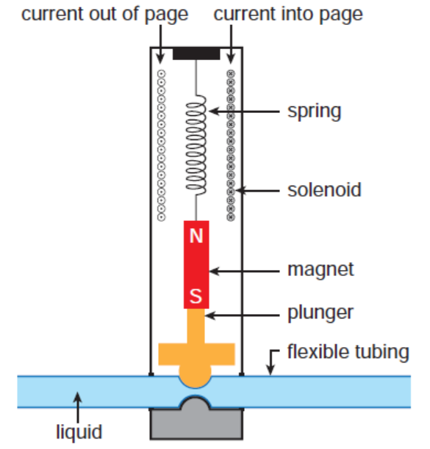

A current in the solenoid causes the magnet attached to the plunger to be pulled up, opening the flexible tubing. When the current is turned off, the spring pushes the magnet attached to the plunger down, closing the flexible tubing.

a) *On the diagram below*, draw the magnetic field lines produced by the current in the solenoid.

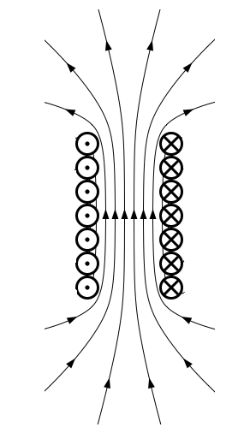(2 marks)

Correct Shape (uniform spacing in coil and curved lines at ends ) (1)

Direction to top of page (1)

b) Explain how the current in the solenoid causes the flexible tubing to open?

(3 marks)

Current creates a magnetic field around coil,

with a south pole at lower end, (1)

resulting in the attraction of the magnet,

moving it towards the top of the page, (1)

and reducing the compressive force on the tubing

thus opening the tubing. (1)

9. (6 marks)

A negatively charged sphere of mass 0.00500 kg is floating above another sphere of equal charge. Calculate the number of electrons on each sphere if their centres are separated by 0.300 m.

$${Weight}_{sphere}=mg=0.005 ×9.8$$

= 4.90 x 10-2 N down (1)

To float ⇒ Felectrostatic balances weight

$F= \frac{1}{4 {}_{0}} × \frac{q_{1 }q_{2}}{r^{2}}= W_{sphere}$ (1)

i.e. $\frac{1}{4 8.85 × {10}^{-12}} × \frac{ q^{2}}{{0.30}^{2}}=4.90 × {10}^{-2}$ (1)

⇒ q = 7.00 x 10-7 C (1)

∴ (1)

= 4.38 x 1012 electrons (1)

10. (5 marks)

A current balance is a device used to measure the force of repulsion (F) between two identical oppositely directed currents (I) in parallel conductors of a certain length (L), separated by a certain distance (R). The relationship between the force and the current is:

 where μ0 is the permeability of free space.

In an experiment designed to measure the permeability of free space, a student obtained the following graph when the conductors where 30.0 cm long, and separated by 15.0 mm.

Use the graph and the relationship to calculate the permeability of free space. **You must show full working to be awarded all marks.**

LOBF 1 mark

Gradient = (y2 – y1) / (x2 – x1) = (1x 0.001 – 0 ) / (148 – 0)

= 6.76 x 10-6 NA-2 1 Mark

x = 1 mark

= 6.67 x 10-6 x 1 mark

= 2.12 x 10-5 1 mark

**END OF TEST**